SUB-PS-RESOLUTION STREAK CAMERA BASED ON RF-CAVITY DEFLECTION

V.Guidi¹, L.Guidi¹, L.Tecchio², P.Bak³, P.Logachev³, E.Pyta³, S.Gurov³, Yu.Chernousov⁴

¹Dipartimento di Fisica dell`Universita’ di Ferrara ed INFN, I-44100 Ferrara, Italy.
²Laboratori Nazionali di Legnaro INFN,
I-70125 Padova, Italy.
³Institute of Nuclear Physics, 630090 Novosibirsk, Russia.
⁴Institute of Chemical Kinetics and Combustion, 630090 Novosibirsk, Russia.

Abstract

Application the radio frequency (RF) magnetic field with circular polarization for a deflection of an electron beam in streak camera’s (SC) allows receiving the high time resolution in the wide time domain. In this message problems of creation of such time analyzing device are discussed. The time resolution depends on dispersion scatter electron on speeds on the photo cathode, a space charge of a photocurrent, aberrations of optical system, speed of scanning of a beam in a plane of registration, stability of feeding voltage. Previously experiments on the model of RFSC have shown total influence of the listed factors on the size of a beam in a plane of registration and the time resolution. The time resolution about 700 fs was shown earlier. We have experimented with new prototype of RFSC. As results, pictures of circular and ellipsoidal scanning of a beam are obtained and possibility achievement of time resolution better then 300 fs is demonstrated.
The effect of occurrence "mode-to mode" connection is experimentally observed by direct measurement and connection factor on two-mode cavity of RFSC is fixed.
The data on time of life of the photo cathode are given.

1. INTRODUCTION

The time resolution of RFSC depends on many factors - dispersion scatter electron on speeds on the photo cathode, a space charge of a photocurrent, aberrations of optical system, speed of scanning of a beam in a plane of registration, stability of feed voltage.
Application the RF field with circular polarization in SC for a deflection of an electron beam allows receiving the high time resolution. Instead using deflecting plates of standard SC for beam deflection in this case employee RF cavity. The high sweep speed, which is possible by this method, envisaged sub-ps time resolution [1]. We show some results for the benefit of it.
For usual SC the time resolution falls with increase time duration of light pulses under study. Therefore some fast features inside a long pulse are lost. Some details the idea of expansion of a time range of the device with preservation of the time resolution by application special regime described in the Ref.[2] - the idea a «RF spiral scanning», allowing keeping sub-ps time resolution in a wide time interval . This regime is provided by an appropriate decrease in amplitude for the RF field in the cavities of the camera and getting a spiral scanning of a beam in a plane of registration and thus on the screen.
The deflection system of RFSC contains of two-modes cavity. Due to the property coupling, one mode excites from another. So, in spite of linier beam scanning appears ellipsoidal one. We observed this effect and measured "mode-to mode" connection factor. This parasitic effect may be used in two-mode cavity for division direct and reverse motions a scanning beam at use only one input.
A complete treatment on theoretical basis of the RFSC can be found in Ref.[1].

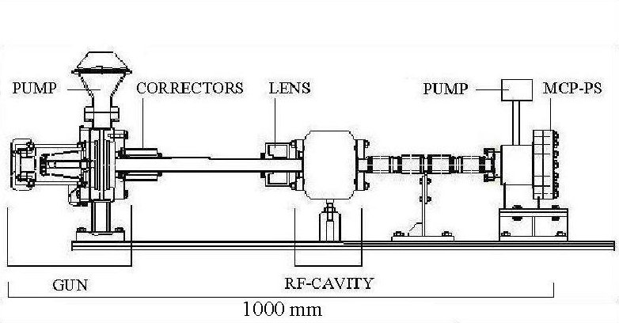

Fig. 1 . Experimental setup.

2. EXPERIMENTAL SETUP

A scheme the model of RFSC is given in Fig.1. It consists of electron gun, deflecting cavity and detection system.
The electron gun equipped with transparent multialkali photocathode, which is illuminated by 5mW … laser and provided about 10 nA at the 80 μm diaphragm, installed after anode of gun. Gun works in pulse regime. Amplitude of high voltage was up to 35 kV.
The deflecting cavity is axially symmetric and made of OFHC copper. The electromagnetic field of the TM₁₁₀ mode excites by magnetic loops. Magnetic fields of two mode inside the cavity are orthogonal one another and shifted by π/2 in phase. As result, one has circular rotating magnetic field with time-constant value. Rotating time τ=1/f, where f- working frequency. In our case f=2856 MHz and τ≅0.35 ns. We is planned to employee f≅11 GHz and τ≅0.1 ns in order to achieve 100 fs time resolution. So higher speed of rotation is very promising on this way.

The detection system is position sensitive detector. This is a two stage MCP coupled to circular phosphor screen 28 mm in diameter. Pulsed high voltage about 4 kV in sum is applied between one of backside of the MCP and the screen. The image on the screen is read out by a charge coupled device (CCD) camera and acquired by computer. The overall resolution of the detector is about 60 μm.

3. RESULTS

We measured transversal cross section of the focused beam on the detector and imaged on the phosphor screen (fig. 2 а-b), time resolution by circular scanning of a maximum diameter (fig. 3), «mode-to mode» connection by ellipsoidal scanning (fig.4) and lifetime of the photo cathode.
Maximum diameter of the circular scanning D (fig. 3) is about 27 mm, which corresponds in our case 975 pixels. One pixel equal 28 μm. Size of spot 2σ is about 5 pixels (fig. 2 a-b), i.e. 140 μm and σ ≅ 70 μm. So, the time resolution τ = σ/πfD on circular scanning is about 300 fs.
«Mode-to mode» coupling factor fixed on the Fig.4. In this case only one input connected to the cavity in order to excite first mode. But due to «mode-to mode» coupling one see exciting of two mode and as a result ellipsoidal scanning of beam. The size of semi-axis of the ellipse L₁, L₂ is proportional to the amplitude of magnetic field every mode. Relation between ellipse’s axes is a relation between magnetic fields. «Mode-to mode» coupling coefficient is [3]: k_{c}=(1+k₂)B₂/B₁Q₂, where k₂, Q₂ are correspondingly the coupling coefficient with line and quality factor second mode. In our case k₂≅1, B₂/B₁≅L₂/L₁≅0.2, Q₂=16000. So, k_{c}≅1.25•10^{–4}. This so little coupling coefficient is not show itself on the visible
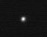
Fig. 2 (a) . Focused beam on the phosphor screen .

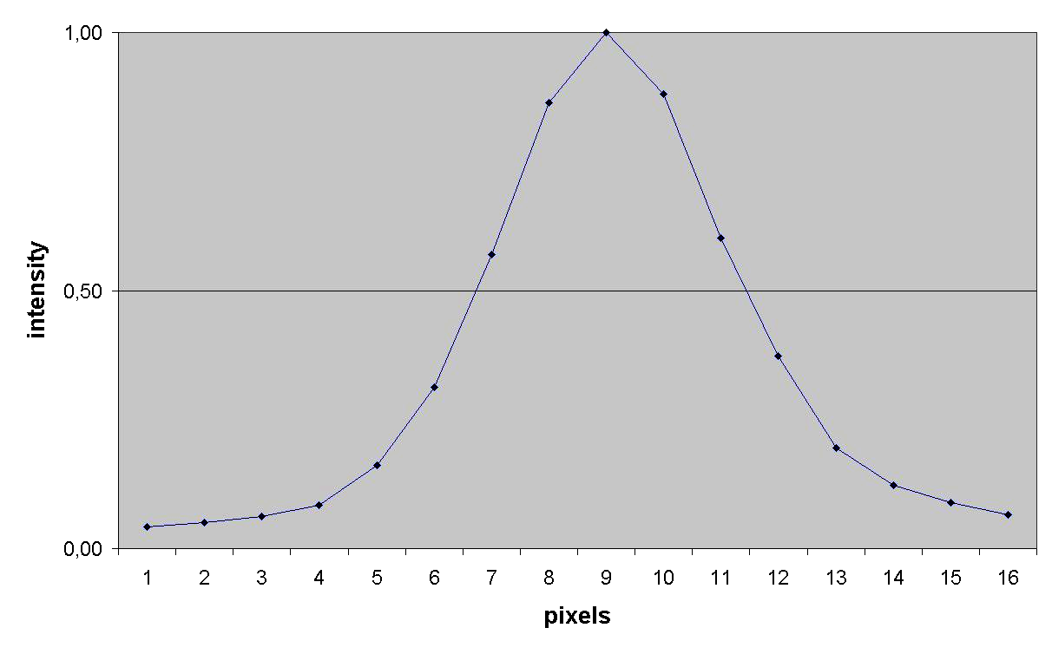
Fig. 2 (b). Focused beam cross section.

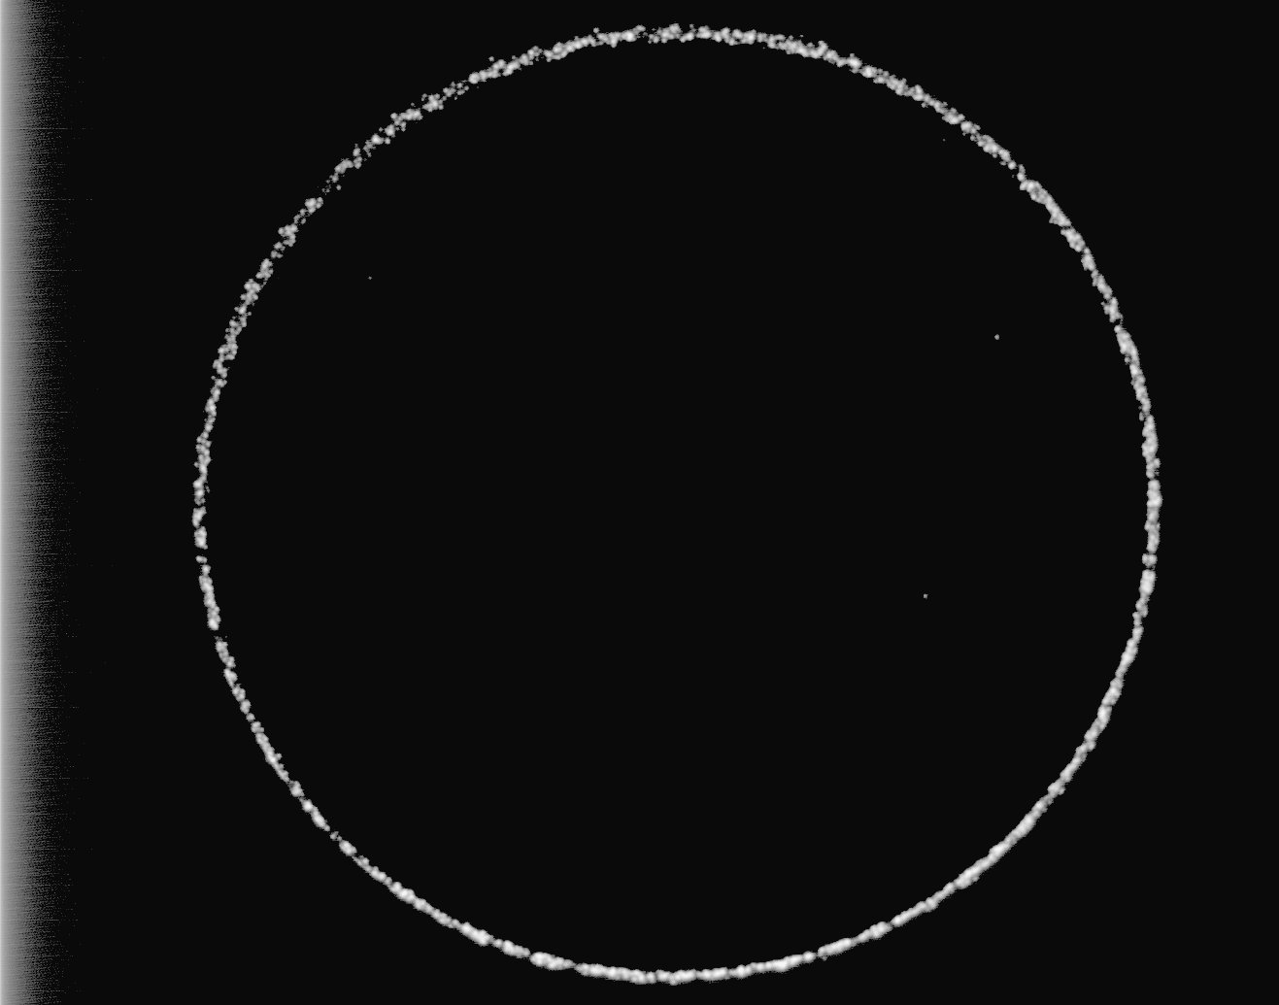
27 mm

Fig. 3. Image of circular scanning.

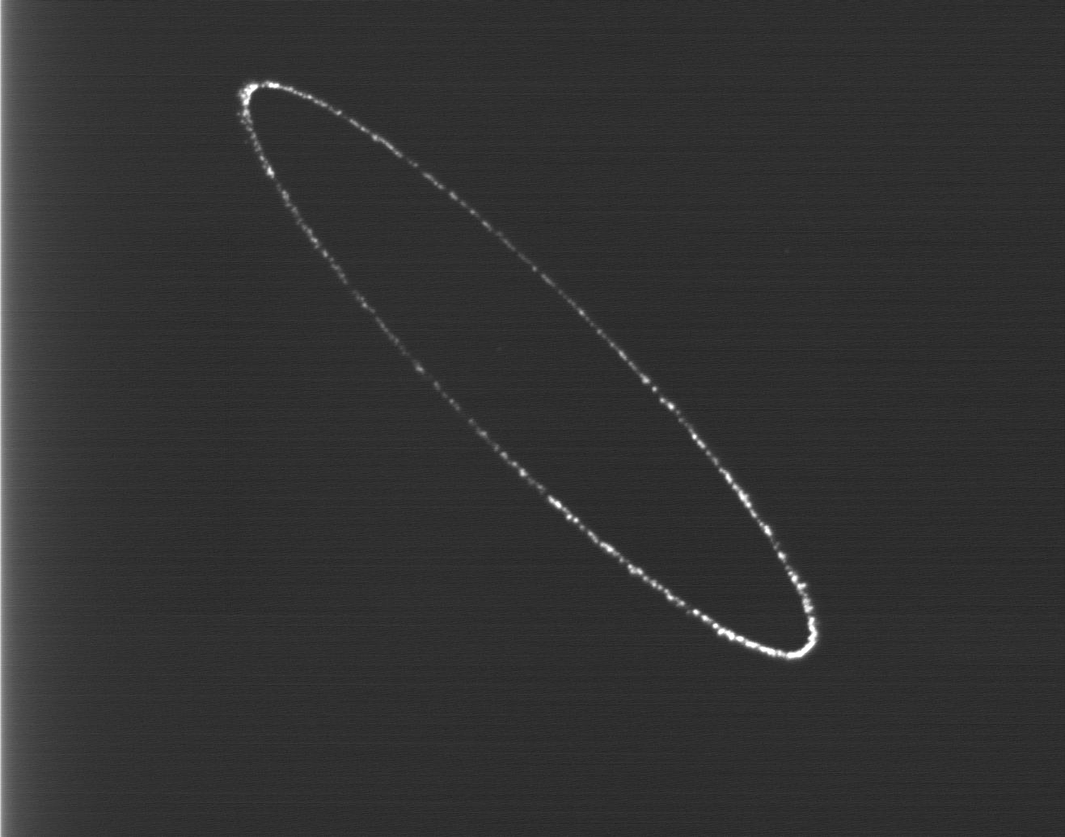
Fig. 4 . Ellipsoidal scanning.

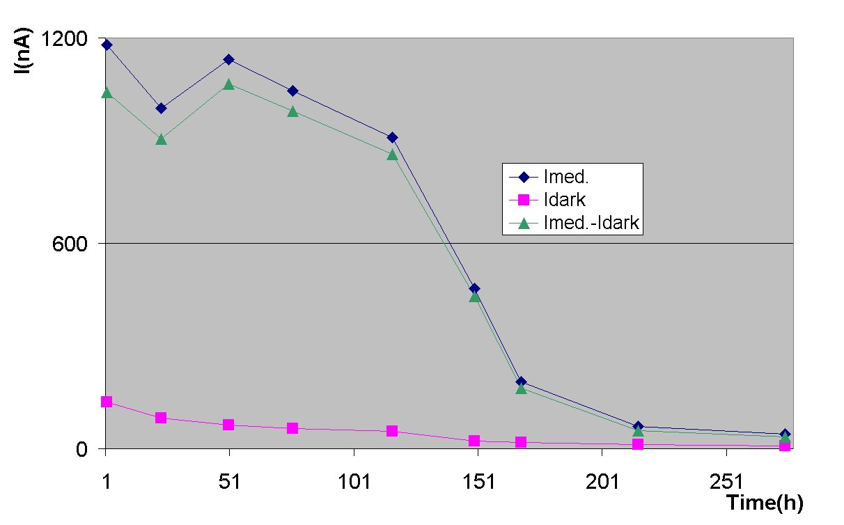
Fig. 5. Photo-cathode life time .

transient RF possess in the cavity, but easily measurable by ellipsoidal beam scanning. This parasitic effect may be used in two-mode cavity for division direct and reverse motions a scanning beam at use only one input. By changing the frequency of second mode one can adjust the division from 0 up to any maximum, devoted from coupling coefficient k_{c}.
The data on time of life of the photo cathode are given on Fig.5. Quantum efficiency newly photo cathode is about 5•10⁻⁴. Now the work under multialkali photo-cathode is in progress.

4. CONCLUSIONS

We have take a step for a way of creation radio-frequency streak camera for studing fast light processes in the femtosecond time domain. Possibility achievement 300 fs time resolution was demonstrated.
The effect exiting two modes in RFSC cavity by one RF input fixed and «mode-to mode» coupling coefficient by circular scanning is measured.
Expected progress in creation of the photocathode and moving to higher frequencies promises developing RFSC with 100 fs time resolution.

5. REFERENCES

[1]. A.V.Aleksandrov et.al., Rev.Sci.Instrum.70(1999)2622.

[2].Y.D.Chernousov et.al., submitted to NIMA.

[3]. V.I.Ivannikov et.al., Tech.Phys.41(1996)493(Translation of Zh.Tech.Phys.41(1996)162(in Russian)).

